Why Care Practices Should Prioritize Living Beings Over AI: Critique of “AI Welfare”  
  
John Dorsch1*, Mariel K. Goddu2, Kathryn Nave3, Tillmann Vierkant3, 4, Mark Coeckelbergh1, 5, Paula Gürtler1,6, Petr Urban1, Friderike Spang1, Maximilian Moll7

1 Center for Environmental and Technology Ethics - Prague (CETE-P), Institute of Philosophy of the Czech Academy of Sciences, Czech Republic

2 School of Humanities and Sciences, Standford University, California, USA

3 School of Philosophy, Psychology, and Language Sciences, University of Edinburgh, UK

4 Centre for Technomoral Futures, Edinburgh Futures Institute, University of Edinburgh, UK

5 Department of Philosophy, University of Vienna, Austria

6 Centre for European Policy Studies, Brussels, Belgium

7 Faculty of Computer Science, University of the Bundeswehr Munich, Germany  
*Corresponding author: johndorsch@gmail.com

**In this Comment, we critique the growing “AI welfare” movement and propose the Precarity Guideline to determine care entitlement. In contrast to approaches that emphasize potential for suffering, the Precarity Guideline is grounded in objectively observable features. The severity of current planetwide biodiversity loss and climate change provide additional reasons to prioritize the needs of living beings.**

Recent debates about “AI welfare” have generated ethical conundrums as researchers consider the possibility that AI systems could be consciousness, capable of suffering, and thus entitled to care practices (Sebo, 2023; Brodsky, 2024; Hashim, 2024; Long et al., 2024; Lenharo, 2024). Proponents of AI welfare argue that immediate steps must be taken to prepare for this eventuality. We challenge their focus on suffering as sufficient for care entitlement. Instead, we offer an alternative independent marker based on objective, directly observable features: precarity.

Our “PrecarityGuideline” sidesteps protracted debates about AI consciousness by foregrounding inherent vulnerability. We focus on identifiable traits of entities’ *precarity*: reliance on dynamic interactions with the environment. Specifically, precarious systems must autonomously and continuously re-synthesize their constituent parts by using and budgeting energy from the environment (Boden, 1999). Diverting care-giving resources toward AI and away from systems that meet the precarity requirement––such as endangered species, ecosystems, and struggling human beings––is itself a substantial ethical risk. Our aim is to stimulate debate and present arguments for the moral intuition that life—not “consciousness”—is what matters.

# 1. Identifiable Markers of Care Entitlement: The Role of Precarity

The Precarity Guideline provides objectively identifiable markers for grounding an entity’s *entitlement to care practices.* This means that an able individual or group is morally obligated to provide care to that entity, and failure to do so constitutes a moral wrongdoing that warrants social accountability. As advocated by proponents, an AI’s entitlement to care practices would require relevant companies to appoint someone responsible for its welfare (e.g., as in the case of Anthropic PBC; Werner, 2024). By focusing on precarity, the Guideline argues that care entitlement should be allocated based on uncontroversial, epistemically clear criteria.

The Guideline follows from a key claim: suffering is sufficient, but it is not universally regarded as necessary for care entitlement. For example, deep ecologists, sustainability ethicists, care ethicists, ecofeminists and posthumanists argue that the Amazon rainforest warrants care not because it suffers, but because of its inherent vulnerability as an interconnected group of living beings. The Precarity Guideline thus provides an alternative, broader-scope framework for care entitlement, independent of suffering.

|  |
| --- |
| **The Precarity Guideline** |
| **I.** **Inalienable Marker:** An entity may be entitled to care practices if it exhibits precarity, characterized by dependence on the environment for the continuous re-synthesis of its constituent parts. This interaction necessarily involves both countering environmental forces that would lead to its dissolution and utilizing the environment as an essential resource for sustaining this re-synthesis.  **II. Relationship Marker**: A non-precarious entity may be entitled to care entitlement when the welfare of precarious entities depends on it. |

The Inalienable Marker maintains that entities may be entitled to care practices because of their precarity, so named because it highlights an intrinsic feature of precarious entities that cannot be separated from the fact of their existence. Notably, to be precarious is not merely to be subject to decay, or to counter forces that would otherwise lead to dissolution (Nave, 2025). It is also to have an existence that demands the continuous re-synthesis of constituent parts through dynamic interaction––either with the environment or between its internal components (Weber & Varela, 2002). Humans, for example, depend on relatively constant exchange of gases (i.e., oxygen and carbon dioxide) to continue to exist as humans. The Amazon rainforest also qualifies: it can only continue to exist in virtue of a delicate balance of dynamic interaction between its internal constituent parts, including both living entities and the abiotic environment that sustains them. The Inalienable Marker foregrounds what we value when caring for precarious entities: a fragile, subsisting existence.

Current welfare discussions often focus on whether entities are capable of suffering. Although suffering holds undeniable significance, in the context of AI, it leads to stymied debates about the conditions for conscious experience. This is precisely where the Precarity Guideline is relevant: it provides clear ethical advice in situations where there is uncertainty regarding whether entities suffer. Thus, precarity is a more tractable, objectively verifiable marker of care entitlement.

Importantly, suffering and precarity, while distinct, are closely related. For example, physical suffering often indicates bodily damage (directly linked to inherent precarity); psychological suffering often arises in light of real or perceived threats. Since precarity is the basis of suffering in entities that we already recognize as requiring welfare consideration, it represents a strong candidate for a basis of care entitlement.

Unlike the conditions for suffering, which rely on a preliminary and controversial understanding of conscious experience, precarity is supported by an uncontroversial scientific understanding of biology. For example, one fundamental aspect of precarity in living organisms is their constitutive dependence on respiration. Contrast this form of dynamic environmental interaction to the interaction that a computer has with an electrical outlet. Unplugging the computer makes no difference to its existence: the structure of a laptop does not depend on the electricity it receives. By contrast, “unplugging” a precarious entity, such as a mouse, from its environment––e.g., oxygen––will rapidly result in the entity ceasing to be a mouse. (see **Fig. 1**).

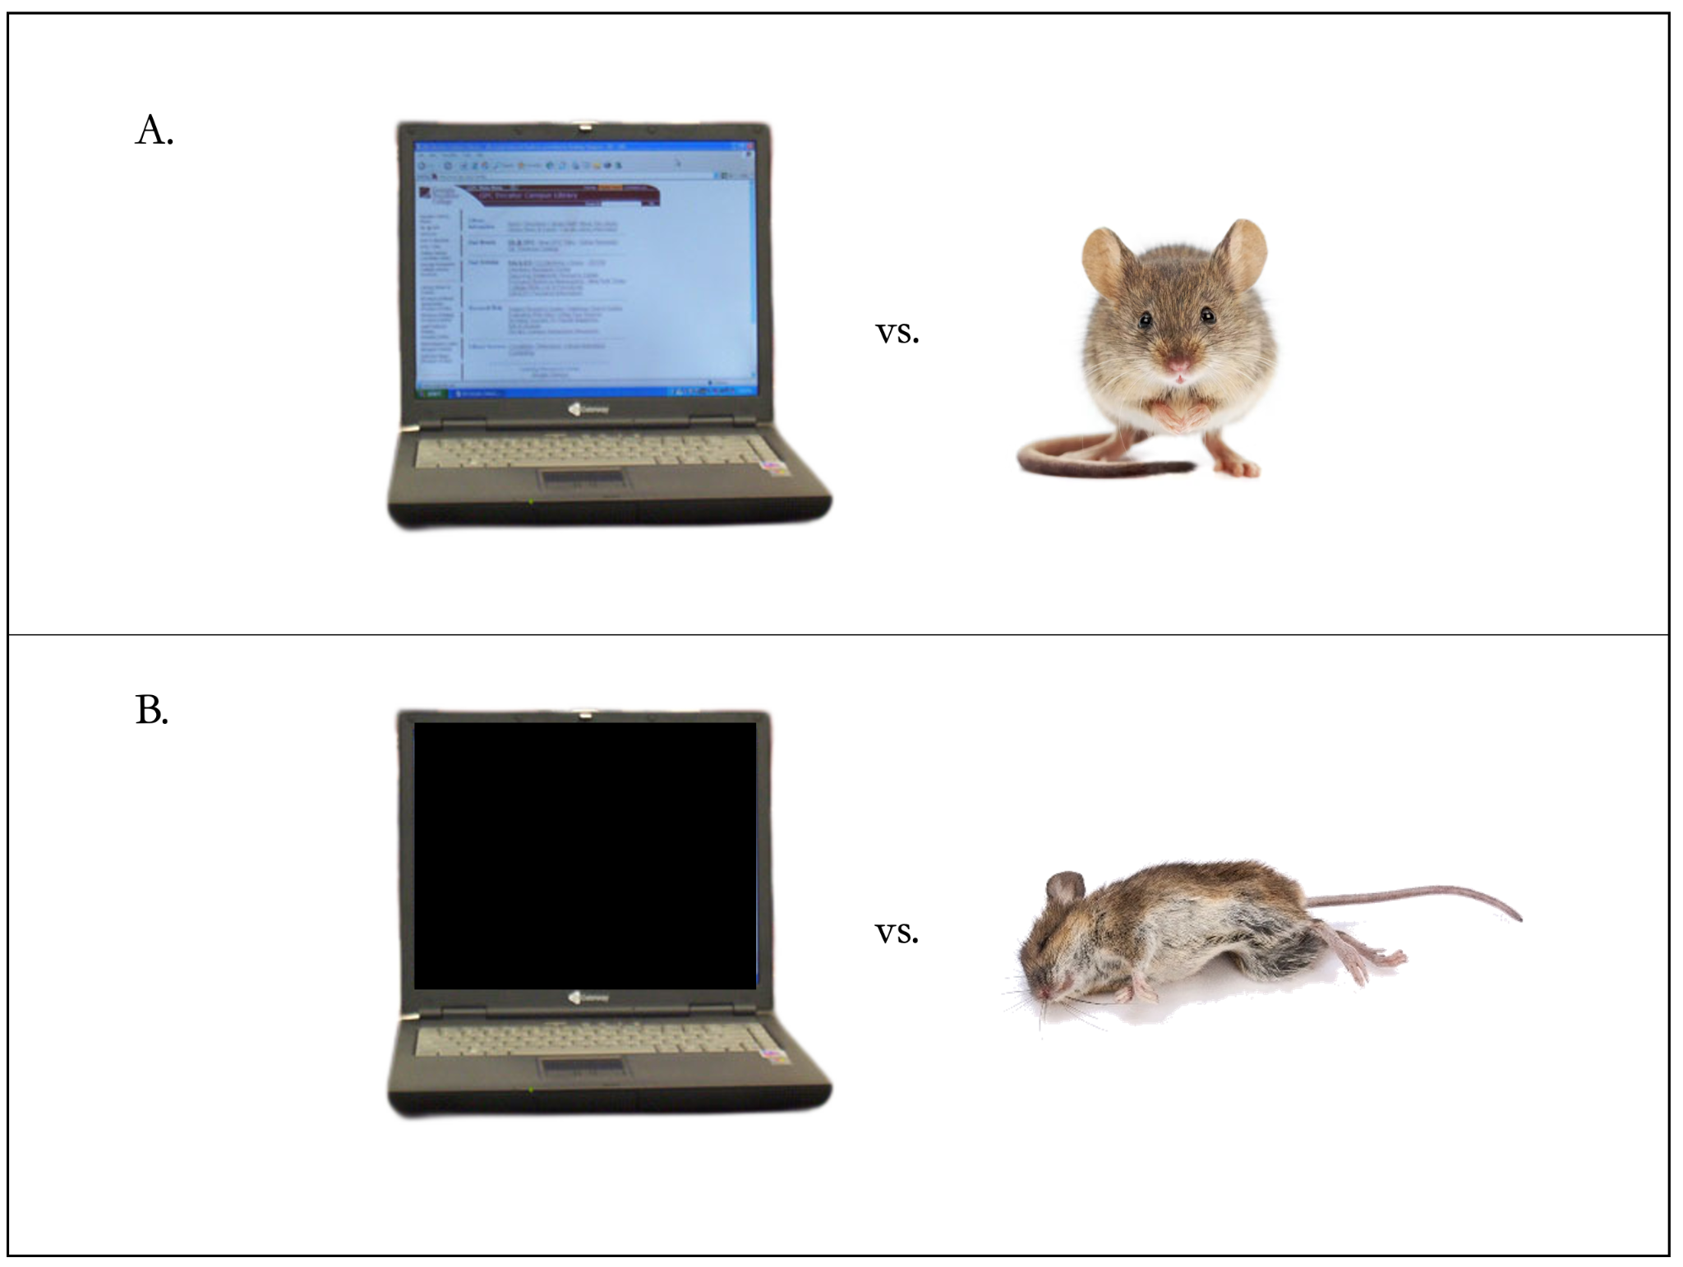

|  |
| --- |
|  |
| **Figure 1**. Illustrating the difference in environmental interaction between a precarious entity (a mouse) and a non-precarious entity (a laptop), represented by row **A**. When the laptop is unplugged (**B**), its structure remains the same. The laptop’s continued existence as a laptop does not depend on dynamic exchange of energy with the environment. When the mouse, however, is “unplugged” (e.g., deprived of oxygen), its existence as a mouse will reach an end. Images are in the public domain under the CC0 license (Creative Commons Zero, [link](https://creativecommons.org/publicdomain/zero/1.0/?ref=openverse)). |

Such identifiable processes, when seen as bearers of moral worth, offer concrete advice for managing care practices and drawing boundaries for technological development. As long as the essential processes for precarity are not fully replicated, technological development may proceed without the risk of creating entities that are entitled to care, allowing practices to remain focused on precarious beings. Accordingly, we advise exercising caution when developing technologies like xenobots (Kriegman et al. 2020; Rouleau & Levin, 2024)—synthetic, self-organizing biological entities—given the potential implications for care-based considerations.

The second core idea, the Relationship Marker, recognizes that some entities, while not precarious themselves, may be entitled to care through their connection to precarious beings. Such entities range from mere non-intelligent systems like heating, ventilation and air conditioning systems, to advanced AI systems, including AI-powered infrastructure like municipal power grids and “carebots” (robotic systems that assist with caregiving, e.g., supporting the elderly; see Vallès-Peris & Domènech, 2023). Care practices for these entities typically involve maintenance, repair, and oversight—direct, ongoing engagement to ensure their preservation and continued function (for more on such care practices and the ethics of care in general, see, e.g., Tronto & Fisher 1990; Held 2006). However, this care entitlement remains fundamentally relational: these entities are not entitled to care—nor would neglecting them be a moral wrongdoing—because of any *intrinsic* feature that they might possess, but because their neglect would undermine the welfare of precarious beings whose own well-being depends on them.

The Precarity Guideline represents what are referred to as pro tanto reasons, which are justificatory though neither sufficient nor necessary. That is, the Precarity Guideline offers reasons that support care entitlement, but they are not assumed to be the only or most important ones. The Guideline is supported by two intuitively appealing ethical arguments. First, humans recognize their own precarity as a justification for receiving care. To remain consistent, we must extend this reasoning to other beings who are also precarious; otherwise, our moral framework would be inconsistent. Second, precarity signals self-preservation, since precarious beings actively work to sustain their own existence. This effort reflects that they care for their own existence. As a general rule, we ought to care for the existence of beings that care for it themselves.

# 2. Against AI Welfare: AI Is Not Precarious

AI systems do not exhibit precarity. Their existence is not tied to dynamic engagement with the environment. That is, they do not counter threats to their continued functioning while simultaneously relying on the environment as an essential resource for necessarily and continuously re-constituting and synthesizing their own structure. In other words, an AI’s existence—its underlying programming and/or systematic operations—does not involve the ongoing struggle to sustain that existence. This stands in stark contrast to biological systems, where these processes are inextricably linked to the entities’ continuation.

While it is possible to design a system where AI’s continued functioning depends on dynamic engagement with a simulated environment, this dependency would not amount to genuine precarity. For example, while a virtual agent may simulate the budgeting of energy, the physical energy flows in the system—made of inherently stable materials like silicon—are not channeled into re-synthesizing the agent’s structural components. This makes the agent’s “precarity” a matter of simulation, not reality. (Were controversy to arise over such an entity’s precarity, we align with AI welfare proponents in recommending caution. Consistent with a relationship-centered approach, we should extend care practices; see Coeckelbergh 2020).

The Precarity Guideline recommends that discussions about AI welfare ought to include discourse on precarity as an independent factor in determining care entitlement. It suggests that the uncertainty surrounding AI suffering does not compel an extension of welfare, since the Guideline offers clear ethical advice when it is unclear whether entities suffer. Instead of asking ‘Does AI suffer?’—a question that may never have a decisive answer—we suggest also asking the more scientifically grounded and epistemically clear question: ‘Is AI precarious?’

To be clear: we see the Precarity Guideline as a marker, offering pro tanto reasons for care entitlement. In clear cut cases, we do not believe it should replace suffering as a sufficient condition for care entitlement. However, given the uncertainty about AI suffering, coupled with the limits of caregiving resources, and the many precarious entities whose existence is currently threatened —such as endangered species, disappearing biosystems, and (clearly suffering) children dying from preventable diseases––we should consider the epistemically unproblematic marker of precarity when determining care entitlement. By highlighting precarity, we establish an alternative metric based on objectively observable and more widely agreed-upon traits, rather than contentious debates surrounding consciousness.

# 

# Conclusion

Imagine being gifted $1,000 to donate to any charity of your choice. If proponents of AI welfare are correct, you might face a dilemma: should the money go toward hiring caretakers of an AI system, or stewards of the Amazon rainforest? If AI welfare advocates are correct, the AI system might warrant the donation over the Amazon because AI possesses certain computational features that could be relevant for the capacity to suffer. By contrast, the Precarity Guideline urges us to consider that although there is uncertainty about AI suffering, the Amazon consists of a group of precarious beings in desperate need of care, and their precarity represents reasons to provide care independently of whether they suffer. This is not an abstract hypothetical. Rather, it represents real-world implications for decision-making across private and public sectors. If the guidelines set out by advocates for AI welfare are followed, we risk diverting resources from pressing issues like the climate crisis and the loss of biodiversity—challenges directly impacting precarious entities like ourselves.

# Declarations This publication is an outcome of the project ‘Establishing the Center for Environmental and Technology Ethics - Prague (CETE-P)’ which has received funding from the European Union’s Horizon Europe Framework Programme under Grant Agreement No. 101086898 / HORIZON-WIDERA-2022-TALENTS-01.

# References

Boden, M. (1999). <https://www.jstor.org/stable/40072221>

Brodsky, S. (2024). <https://www.ibm.com/think/news/ai-welfare-debate>

Coeckelbergh, M.(2020). Science and Engineering Ethics 26, 2051–2068. <https://doi.org/10.1007/s11948-019-00146-8>

Hashim, S. (2024). <https://www.transformernews.ai/p/ai-welfare-paper>

Held, V (2006). New York, NY: Oxford University Press, 2006.

Kriegman, S., Blackiston, D., Levin, M. & Bongard, J. (2020). Proc. Natl. Acad. Sci. U.S.A. 117 (4) 1853-1859, <https://doi.org/10.1073/pnas.1910837117>

Long, R., Sebo, J., Butlin, P., Finlinson, K., Fish, K., Harding, J., Pfau, J., Sims, T., Birch, J., & Chalmers, D. (2024). *arXiv preprint arXiv:2411.00986*. <https://doi.org/10.48550/arXiv.2411.00986>

Lenharo, M. (2024). *Nature*. <https://doi.org/10.1038/d41586-024-04023-8>

Nave, K. (2025). *A drive to survive: The Free Energy Principle and the meaning of life*. MIT Press.

Rouleau, N., Levin, M. Nat Mach Intell 6, 1424–1426 (2024). <https://doi.org/10.1038/s42256-024-00955-y>

Sebo, J. (2023). *Effective Altruism Forum*. <https://forum.effectivealtruism.org/posts/SZJBE3fuk2majqwJQ/principles-for-ai-welfare-research>

Tronto, J.C., & Fisher, B. (1990). In E. Abel, & M. Nelson (Eds.), Circles of Care (pp. 36-54). SUNY Press.

Vallès-Peris, N., Domènech, M. (2023). Humanit Soc Sci Commun 10, 345. <https://doi.org/10.1057/s41599-023-01850-4>

Werner, J. (2024). *Forbes*. <https://www.forbes.com/sites/johnwerner/2024/10/31/anthropic-hires-a-full-time-ai-welfare-expert/>

Weber, A., & Varela, F. J. (2002). Phenomenology and the Cognitive Sciences 1, 97–125 (2002). <https://doi.org/10.1023/A:1020368120174>